Target Third year Regular students for section A and B

web programming course

Activities for Client Side Scripting Basics

Overview of Web Scripting basics
Web page is a document, typically written in HTML that is almost always accessible via HTTP
- A client-side script is executed on the client, by the browser. Client-scripting is often used to validate data entered on a form by the user, before the form is submitted to the server
- A server-side script is executed on the server, and generally produces HTML which is then output HTML to the client.
- Server-side Web scripting is mostly about connecting Web sites to back end servers, such as databases.
- This enables two-way communication:
- Client to server: Customer-enter information as request.
- Server to client: Web pages can be assembled from back end-server to give output.

What is HTML?
- The word HTML, stands for Hypertext Markup Language, is the predominant markup language for web pages.
- A markup language is a set of markup tags, and HTML uses markup tags to describe web pages. HTML is written in the form of HTML elements consisting of HTML tags surrounded by angle brackets (e.g. <html>) within the web page content.
- HTML :- Are basically used to design or built the content, structure or visible skeletons of web pages.
- HTML tags usually come in pairs like <b> and </b>, but not always. The first tag in a pair is the start tag or opening tag, the second tag is the end tag or closing tag.
- There are two types of tags:-
  - Empty tag:- type of html tag which has not any close tags such as <br> and <img> tags
  - Container tag:- tag types which have both open and close tags. For instance <body> and <html> tags.
N.B:- HTML tags are not case sensitive; <b> means the same as <B>. both upper and lower-cases of tags in html interpreted similarly. But, the latest web standards follow lowercase tags.
- HTML document can be created using a simple text editor like Notepad, WordPad, Notepade++, sublime,vs-code or any other text editors.
- For example: using Notepad, we can edit HTML program as follows:-:-
Step 1: Open Notepad or other editor.
Step 2: Writing the HTML tags in the new Notepad file, then save using a file extension of .html
Step 3: Double-click on the HTML file to run

Task one :-
N.B:- To execute the client side script code we must install HTML editor after installing successfully create your own folder inside the following path:- C:\Users\meku\Desktop\webcode\your folder name
--->your folder name ----->>take example folder name is hospital
After creating hospital folder in the path C:\Users\meku\Desktop\webcode save All file as extension of“.html” and“.css” for css code and script code in hospital.
Task-two
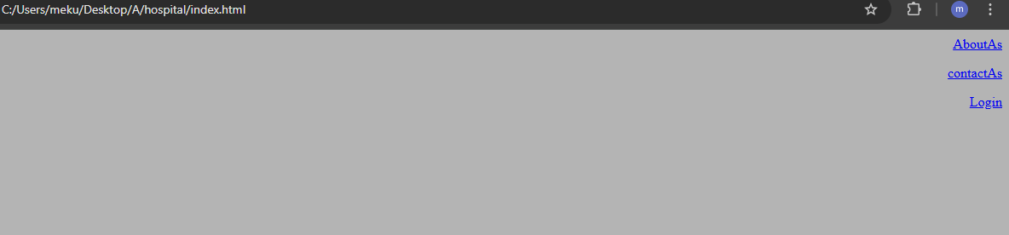
- write above task in web programming language as to display the above pattern and save file as index.html in file:///C:/Users/meku/Desktop/webcode/hospital/index.html
To run html code open with certain browser.
NB:- Those AboutAs ,ContactAs and Login are link tages which redirect into other page. Made using <a>tage</a> anchor tag

<html>
<head><title>index page</title></head>
<body align="right" bgcolor="#b4b4b4">
<div align="right">
<p><a href="about.php">AboutAs</a></p>
<p><a href="contact.php">contactAs</a></p>
<p><a href="login.php">Login</a></p>
</div>
</body>
</html>
- Create developer details on about.html and contact.html to give information to your web site user.
- When some one click login link it will display the following graphics.
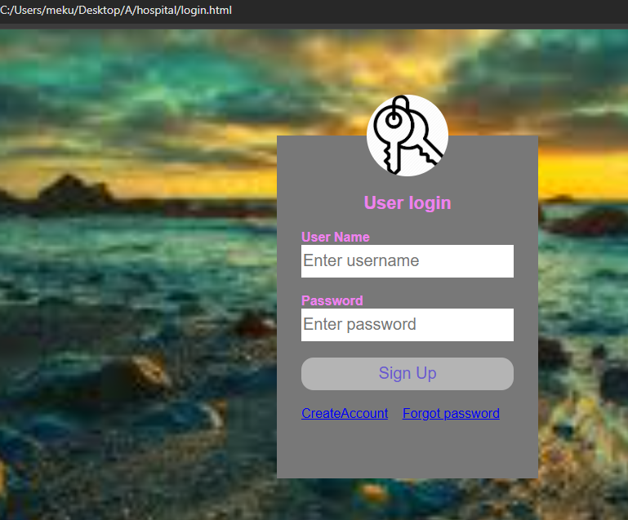

- The source code to display the above login form save ,,,,,,,login.html
<html>
<head>
<title>login design form</title>
<link rel="stylesheet"type="text/css"href="style.css">
<style>
To link our css file into html code fo external css
body{
Giving class or id for div tag to do css
margin:0;
padding:0;
background:url(im.jpg);
To write css code into html we call internal css
background-size:cover;
background-position:center;
font-family:sans-serif;}</style></head>
<body >
<form action="login.php"method="POST" >
<div class="loginbox">
Giving class or id for div tag to do css by class name.
<img src="key.png" class="meku">
<h1>User login</h1>
<p>user name</p>
<input type="text"name="username"placeholder="Enter username"required>
<p>password</p>
<input type="password"name="password"placeholder="Enter password"required>
<input type="submit"name="login"value="Sign Up">
<a href="create_account.php" >CreateAccount</a>&nbsp&nbsp&nbsp
<a href="forgot_password.php">Forgot password</a>
</form></body></html>
- Create the style-sheet code in “style.css” to look good the login form
body{
margin:0;
padding:0;
background:url(im.jpg);
background-size:cover;
background-position:center;
font-family:sans-serif;}
.loginbox{
width:320px;
height:420px;
background:rgb(120, 120, 120);
color:#ee82ee;
top:50%;
left:50%;
position:absolute;
transform:translate(-50%,-50%);
box-sizing:border-box;
padding:70px 30px;
}
.meku{
height:100;
width:100;
border-radius:50%;
position:absolute;
top:-50px;
left:calc(50% - 50px);
}
h1{
margin:0;
padding:0 0 20px;
text-align:center;
font-size:22px;
}
.loginbox p{
margin:0;
padding:0;
text-transform: capitalize;
font-weight:bold;
}
.loginbox input{
width:100%;
margin-bottom:20px;
}
.loginbox input[type="text"],input[type="password"]{
border:none;
border-bottom:1px bottom #ee82ee;
background:#ffffff;
outline:none;
height:40px;
color:#dcdcdc;
font-size:20px;}
.loginbox input[type="submit"]{
border:none;
outline:none;
height:40px;
background:#b4b4b4;
color:#6a5acd;
font-size:20px;
border-radius:15px;}
.loginbox input[type="submit"]:hover{
cursor:pointer;
background:#3cb371;
color:#ffffff;
}
- Some who have not account a click Account Creation Button After clicking Account Creation Button it will display the following layout.
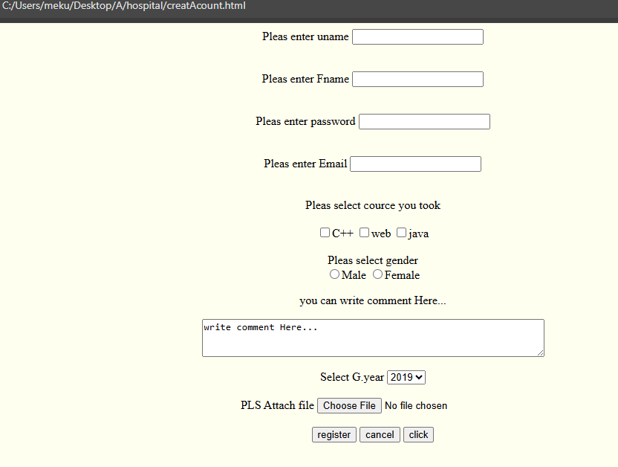

- The source code to display the above Create Account form save as creatAcount.html
<html>
<header><title> wellcome to creatacount page</title>
</header>
<body bgcolor="#fffffff"align="center">
<form action="#"method="POST">
<label>Pleas enter uname</label>
<input type="text"name="uname"required> <br><br><br>
<label>Pleas enter Fname</label>
<input type="text"name="fname"requiredrequiredrequired> <br><br><br>
<label>Pleas enter password</label>
<input type="password"name="pass"requiredrequired> <br><br><br>
<label>Pleas enter Email</label>
<input type="email"name="email"required> <br><br><br>
<label>Pleas select cource you took</label><br><br>
<input type="checkbox"name="c++">C++
<input type="checkbox"name="Web">web
<input type="checkbox"name="java">java<br><br>
<label>Pleas select gender</label><br>
<input type="radio"name="gender" value="Male">Male
<input type="radio"name="gender" value="Female">Female
<p> you can write comment Here...</p>
<textarea cols="60" rows="3" name="comm">
write comment Here...
</textarea><br><br>
<label>Select G.year</label>
<Select name="year"value="2019">
<option value="2019">2019</option>
<option value="2020">2020</option>
<option value="2021">2021</option>
<option value="2023">2023</option>
</Select><br><br>
<label>PLS Attach file</label>
<input type="file"name="file"><br><br>
<input type="submit"name="send"value="register">
<input type="reset"name="reset"value="cancel">
<input type="button"onclick="alert('click me')" value="click">
</form>
</body>
</html>

- Example of code in forgot password page save ,, forgot_password.html
<html>
<body bgcolor="#787878"text="#ffa500">
<p>"wellcome to password reset page"</p>
<p>"write password reset code here"</p>
</body>
</html>
What is CSS?
- CSS stands for Cascading Style Sheet, and it allows us to separate our web sites HTML content from its style.
- As always we use HTML file to arrange the content, but all of the presentation/formatting (fonts, colors, background, borders, text formatting, link effects & so on...) are accomplished within a CSS.
- CSS is a web page layout method that has been added to HTML to give web developers more control over their design and content layout.
- CSS separates the layout and the styles of a web page.
- Styles sheets define HOW HTML elements are to be displayed, just like the font tag and the color attribute in HTML.
Styles are normally saved in external .css files. External style sheets enable us to change the appearance and layout of all the pages in the Web. just by editing one single CSS document.
- CSS Syntax
- A CSS rule has two main parts: a selector, and one or more declarations. The selector is normally the HTML element we want to style. Each declaration consists of a property and a value. The property is the style attribute we want to change. Each property has a value,

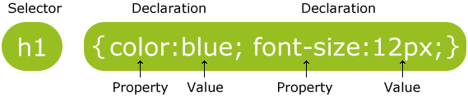
Selector
h1 {
color: white;
text-align: center;
}
property
value
Declaration
- The selector is normally the HTML element/tag we wish to define, the property is the attribute we wish to change, and each property can take a value. The property and value are separated by a colon, and surrounded by curly braces:
body {
colon
Color : black ;
colon
}
- If you have paragraph tag in web site you can style by the following css code.
P {
text-align: center;
color: black;
font-family: arial;
font-size:12px;
}
- NB :- we must write semicolon at the end of css code after value.
- CSS Comments
Comments are used to explain code, and may help us when we edit the source code at a later date. CSS comments, like other programming languages comments, are ignored by browsers.
A CSS comment begins with /* and ends with */ like this

Three Ways to Insert CSS
- External style sheet
- Internal style sheet
- Inline style

An internal style sheet may be used if one single page has a unique style inside the tag.
Example:-<img src=”a.jpg” style=background-image:blue;> only inside specific tag.

Internal styles are defined within the <style> element, inside the <head> section of an HTML page: use example written before.

External style sheet
Each page must link to the style sheet using the <link> tag, which goes inside the head section:
<link rel=”stylesheet” type=”text/css” href=”filename.css”/>

Task:-3

JavaScript Programming
- JavaScript is the most popular scripting language on the internet, and works in all major browsers, such as Internet Explorer, Firefox, and Opera.
- Scripting languages are usually interpreted rather than compiled. That means that a software routine called an interpreter translate a program’s statements into machine code, code understandable by a particular type of computer, before executing them every time the program is run.

- Do all on handout.

